Program 21:
AIM:
To randomly split iris dataset into train/test (80/20), build logistic regression (Species ~ Petal.Length + Petal.Width), predict, and evaluate with confusion matrix.
PROCEDURE:
Step 1: Open RStudio or R console on your computer.
Step 2: Load the nnet package and the built-in dataset iris available in R.
Step 3: Set a random seed and randomly select 80% of the rows for training; keep the remaining 20% for testing.
Step 4: Use the multinom function to build a logistic regression model where Species is predicted using Petal.Length and Petal.Width.
Step 5: Use the predict function to predict the Species of the test data.
Step 6: Create the confusion matrix using the table function to compare predicted and actual species.
Step 7: Calculate and print the accuracy of the model.
PROGRAM (R CODE INPUT):
library(nnet)
data(iris)
set.seed(123)
idx <- sample(1:nrow(iris), 0.8 * nrow(iris))
train <- iris[idx, ]
test <- iris[-idx, ]
model <- multinom(Species ~ Petal.Length + Petal.Width,
data = train, trace = FALSE)
pred <- predict(model, test)
cm <- table(Predicted = pred, Actual = test$Species)
print(cm)
accuracy <- sum(diag(cm)) / sum(cm)
print(paste("Accuracy:", round(accuracy, 4)))
OUTPUT: 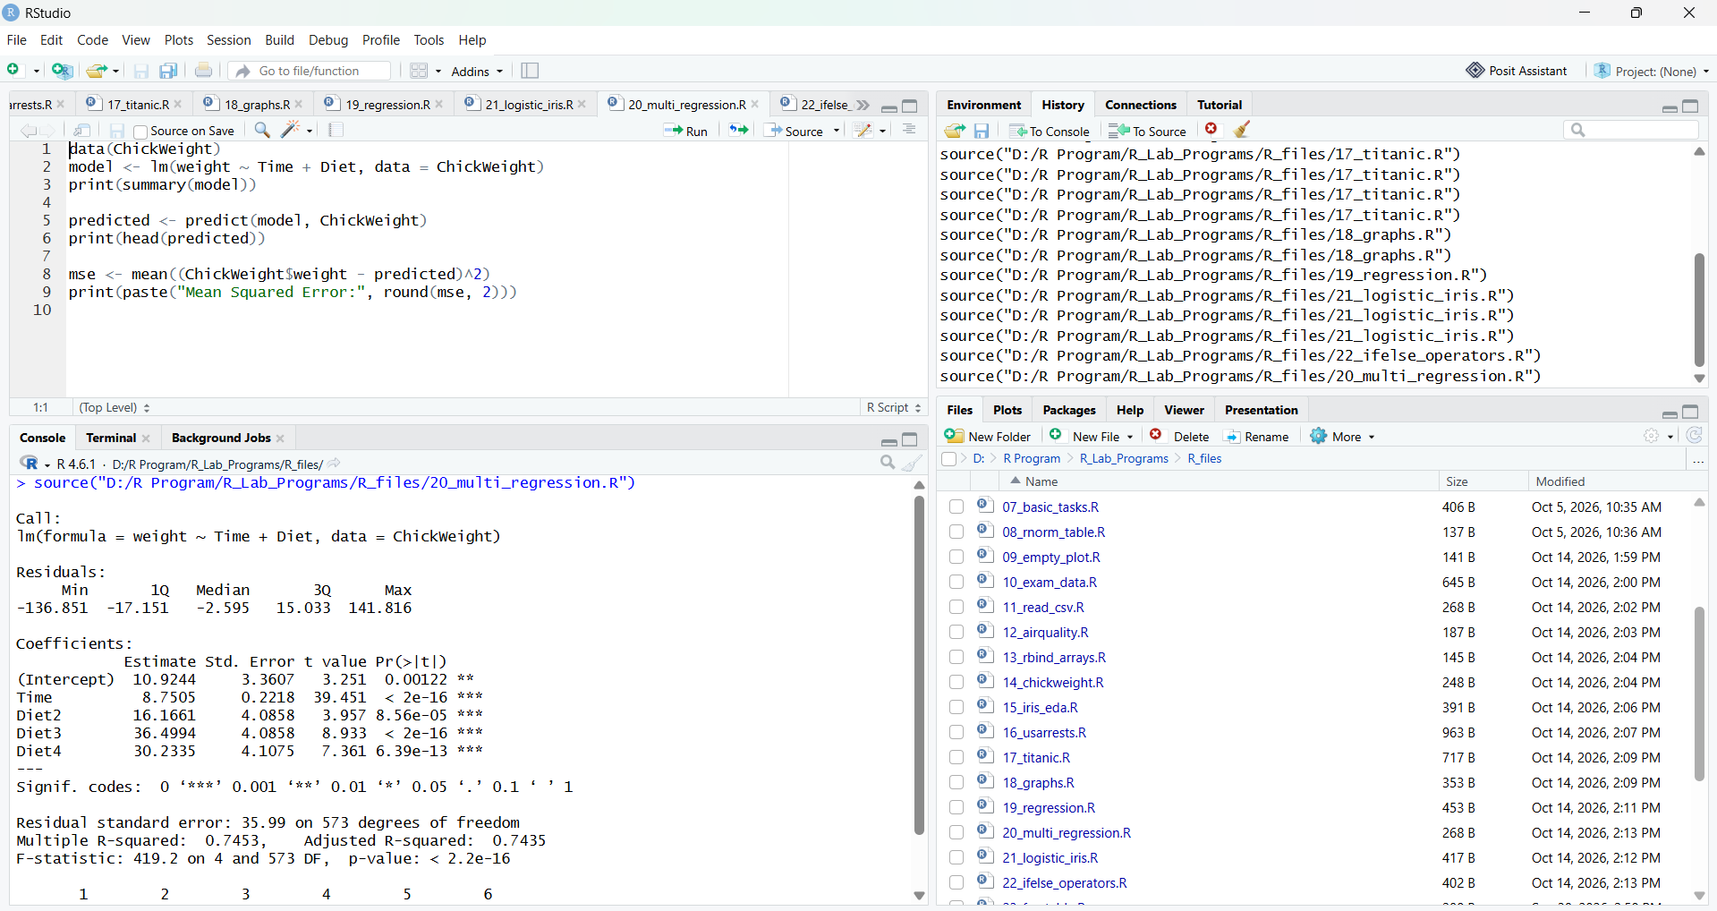

RESULT:
Hence the output is verified successfully.
Program 22: If-Else and Arithmetic & Boolean Operators
AIM:
To write an R program using if-else to check whether a number is positive, negative, or zero, and to demonstrate arithmetic and boolean operators.
PROCEDURE:
Step 1: Open RStudio or R console on your system.
Step 2: Assign a value to a variable and use if-else statements to check whether it is positive, negative, or zero.
Step 3: Store the result in a variable.
Step 4: Create two variables and perform arithmetic operations (addition, subtraction, multiplication, division) on them.
Step 5: Use boolean operators (>, ==, !=) to compare the two variables.
Step 6: Print the result and the values of all operations.
PROGRAM (R CODE INPUT):
num <- 5
if (num > 0) {
result <- "Positive"
} else if (num < 0) {
result <- "Negative"
} else {
result <- "Zero"
}

a <- 10
b <- 3
sum_val <- a + b
diff_val <- a - b
prod_val <- a * b
div_val <- a / b
bool1 <- (a > b)
bool2 <- (a == b)
bool3 <- (a != b)

print(result)
print(sum_val)
print(diff_val)
print(prod_val)
print(div_val)
print(bool1)
print(bool2)
print(bool3)
OUTPUT:
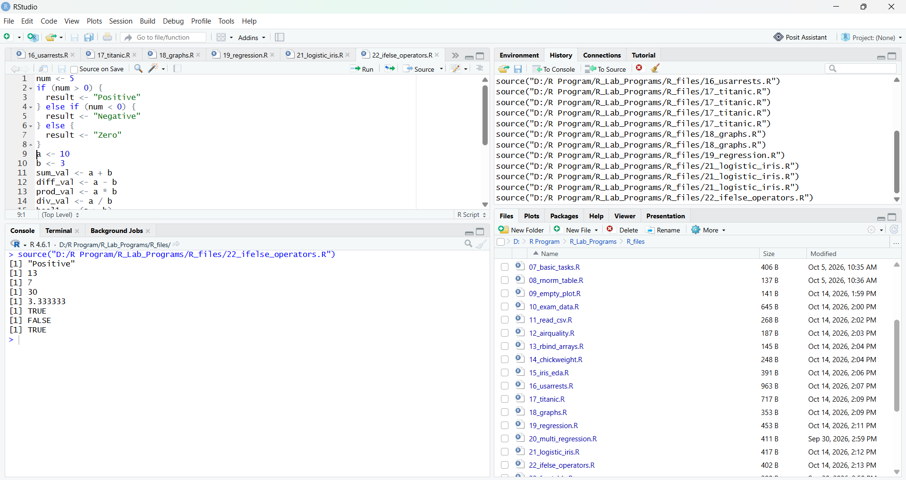
RESULT:
Hence the output is verified successfully.
Program 23: For Loop - Printing Multiplication Table
AIM:
To write an R program using a for loop to print the multiplication table of a number.
PROCEDURE:
Step 1: Open RStudio or R console on your system.
Step 2: Assign a number to a variable for which the multiplication table is required.
Step 3: Use a for loop to iterate from 1 to 10.
Step 4: Inside the loop, multiply the number by the loop variable and print each line using the cat function.
Step 5: Use another for loop to add the numbers from 1 to 10 and store the sum in a variable.
Step 6: Print the total sum.
PROGRAM (R CODE INPUT):
num <- 5
for (i in 1:10) {
result <- num * i
cat(num, "*", i, "=", result, "\n")
}
total <- 0
for (i in 1:10) {
total <- total + i
}
print(total)
OUTPUT:
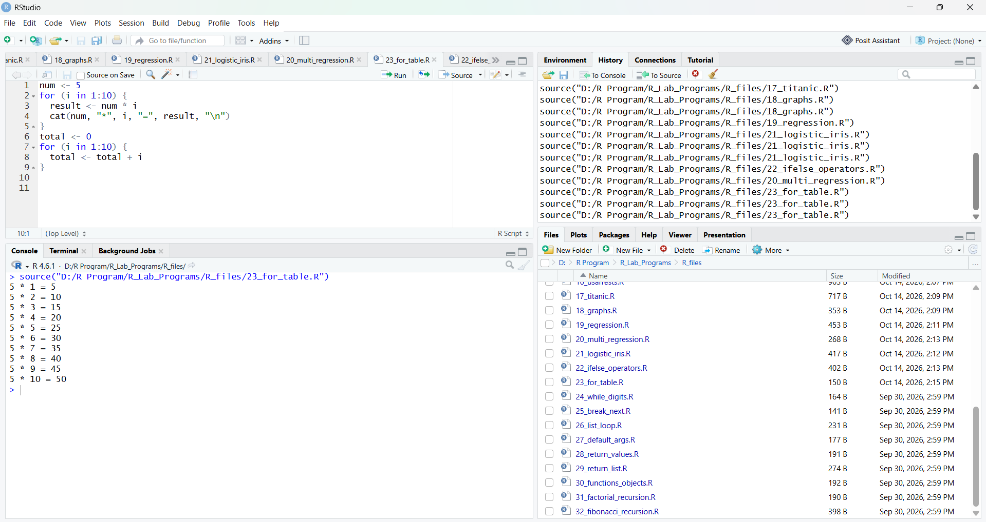
RESULT:
Hence the output is verified successfully.
Program 24: While Loop - Sum of Digits
AIM:
To write an R program using a while loop to find the sum of digits of a number.
PROCEDURE:
Step 1: Open RStudio or R console on your system.
Step 2: Assign a number to a variable and initialize a variable to store the sum as 0.
Step 3: Use a while loop that runs as long as the number is greater than 0.
Step 4: Inside the loop, find the last digit using the modulus operator (%%) and add it to the sum.
Step 5: Remove the last digit from the number using integer division (%/%).
Step 6: After the loop ends, print the sum of the digits.
PROGRAM (R CODE INPUT):
num <- 1234
total <- 0
while (num > 0) {
digit <- num %% 10
total <- total + digit
num <- num %/% 10
}
print(total)
OUTPUT:
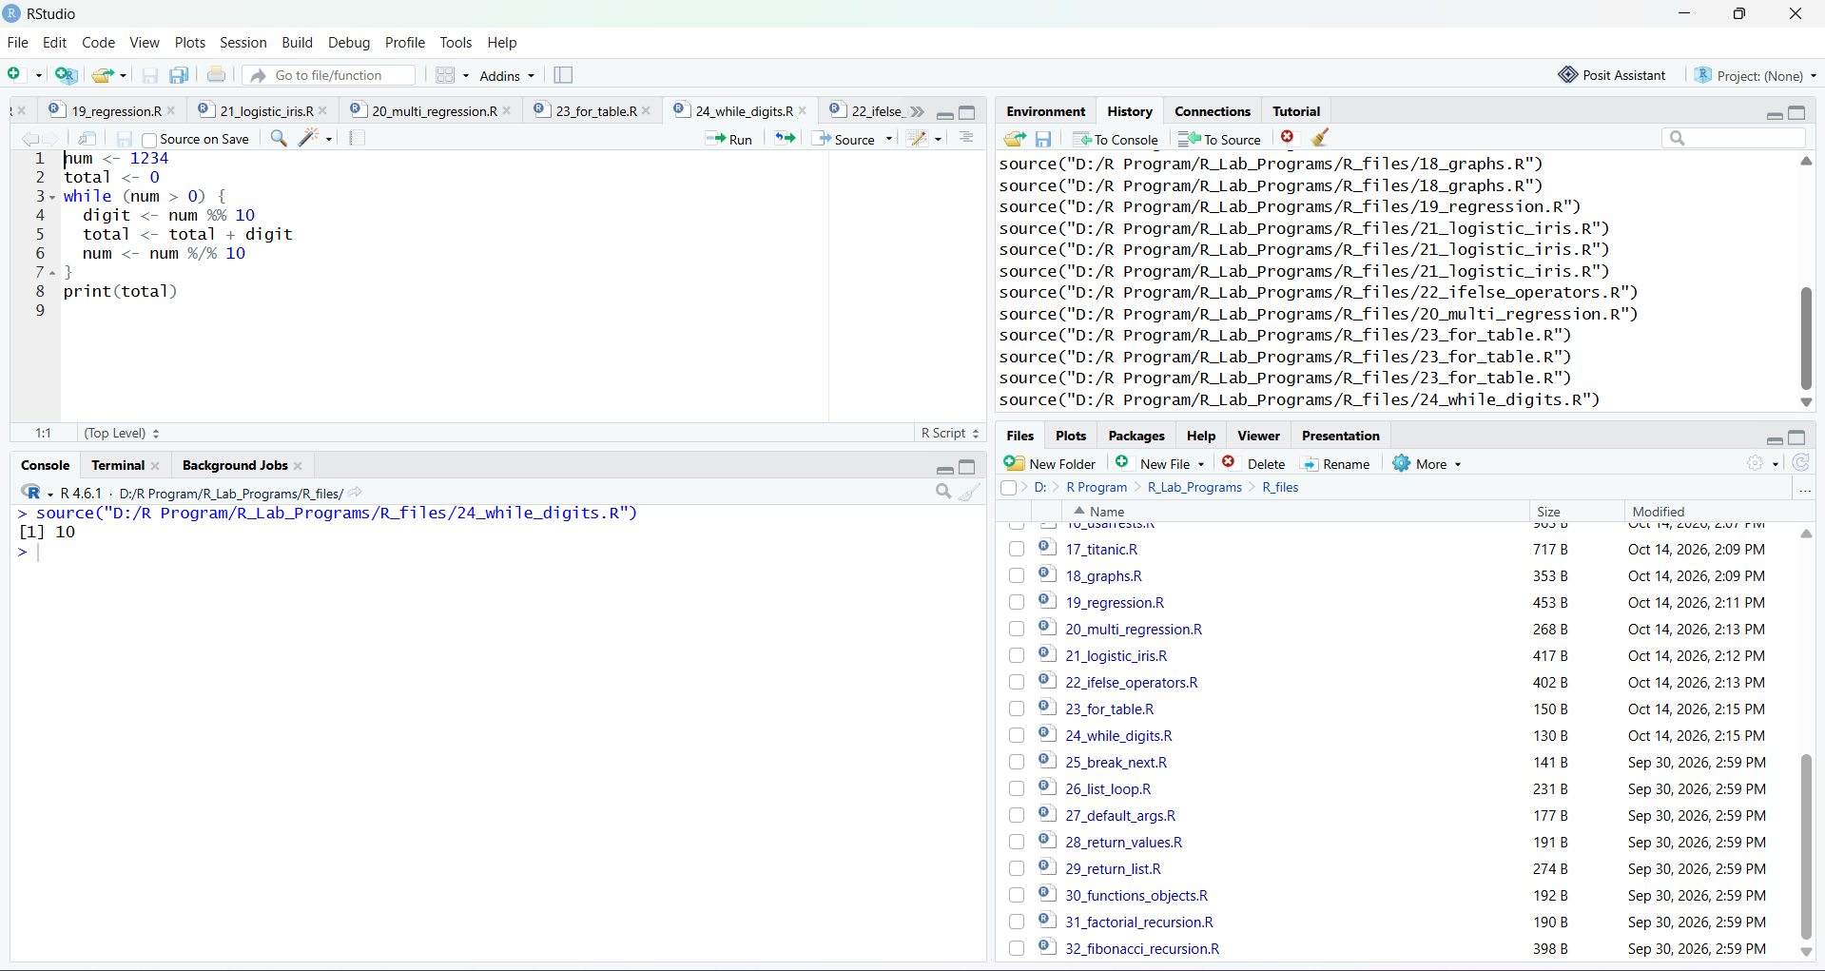
RESULT:
Hence the output is verified successfully.

Program 25: Control Statements - break and next
AIM:
To write an R program to demonstrate break and next statements in loops.
PROCEDURE:
Step 1: Open RStudio or R console on your system.
Step 2: Use a for loop to iterate from 1 to 10.
Step 3: Use the next statement to skip the iteration when the value is 3.
Step 4: Use the break statement to stop the loop when the value is 8.
Step 5: Print the remaining values of the loop variable.
Step 6: Observe that 3 is skipped and the loop stops before printing 8.
PROGRAM (R CODE INPUT):
for (i in 1:10) {
if (i == 3) {
next
}
if (i == 8) {
break
}
print(i)
}
OUTPUT:
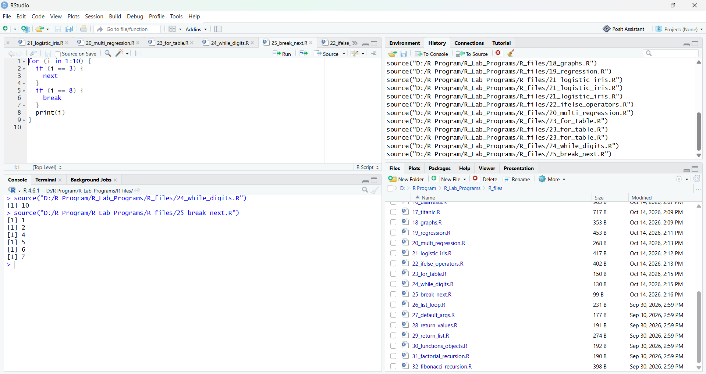
RESULT:
Hence the output is verified successfully.
Program 26: Looping Over Non-Vector Sets (Lists)
AIM:
To write an R program to loop over elements of a list.
PROCEDURE:
Step 1: Open RStudio or R console on your system.
Step 2: Create a named list containing numeric values.
Step 3: Use a for loop to iterate over each element of the list and print it.
Step 4: Get the names of the list elements using the names function.
Step 5: Use another for loop to iterate over the names and print each name with its value using the cat function.
Step 6: Observe the output of both loops.
PROGRAM (R CODE INPUT):
my_list <- list(a = 10, b = 20, c = 30)
for (item in my_list) {
print(item)
}
names_list <- names(my_list)
for (name in names_list) {
cat(name, "=", my_list[[name]], "\n")
}
OUTPUT:
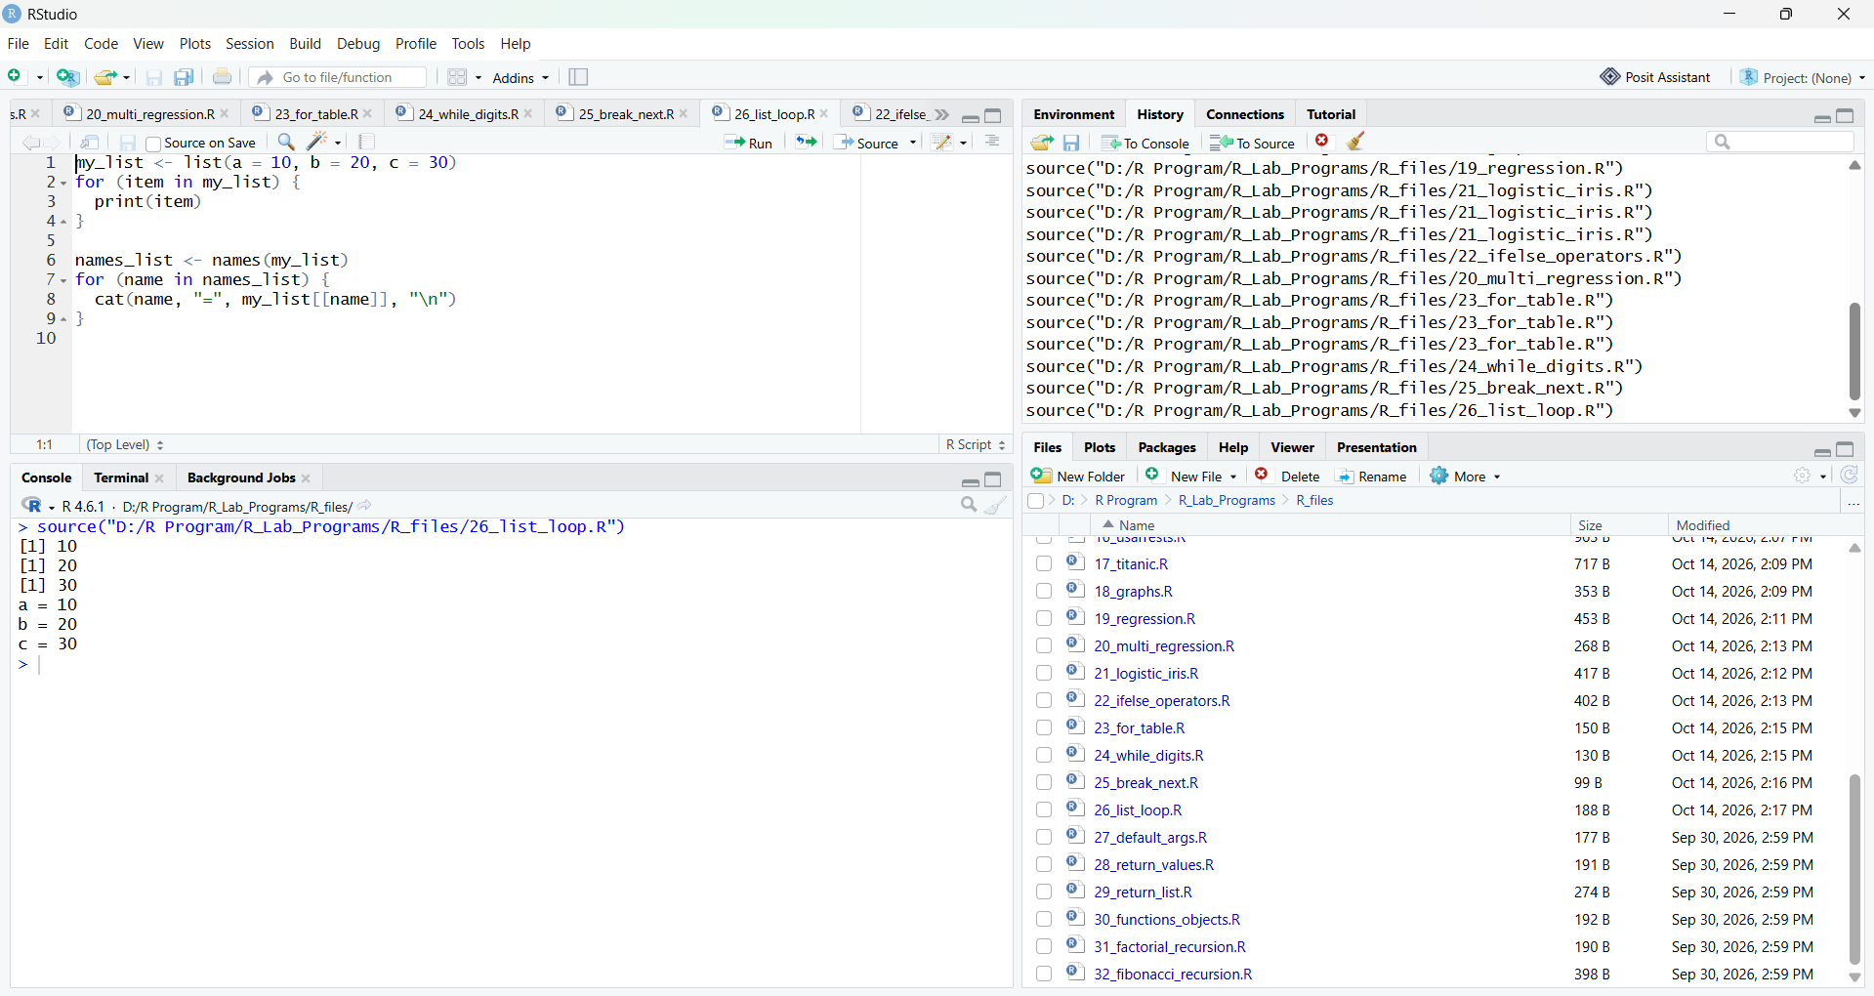RESULT:
Hence the output is verified successfully.
Program 27: Functions with Default Argument Values
AIM:
To write an R function with default argument values.
PROCEDURE:
Step 1: Open RStudio or R console on your system.
Step 2: Define a function named add_numbers with two arguments, where the second argument has a default value of 10.
Step 3: Inside the function, add the two arguments and return the result.
Step 4: Call the function with only one argument so that the default value is used.
Step 5: Call the function again with both arguments so that the default value is overridden.
Step 6: Print the results of both function calls.
PROGRAM (R CODE INPUT):
add_numbers <- function(a, b = 10) {
result <- a + b
return(result)
}
print(add_numbers(5))
print(add_numbers(5, 20))
OUTPUT:
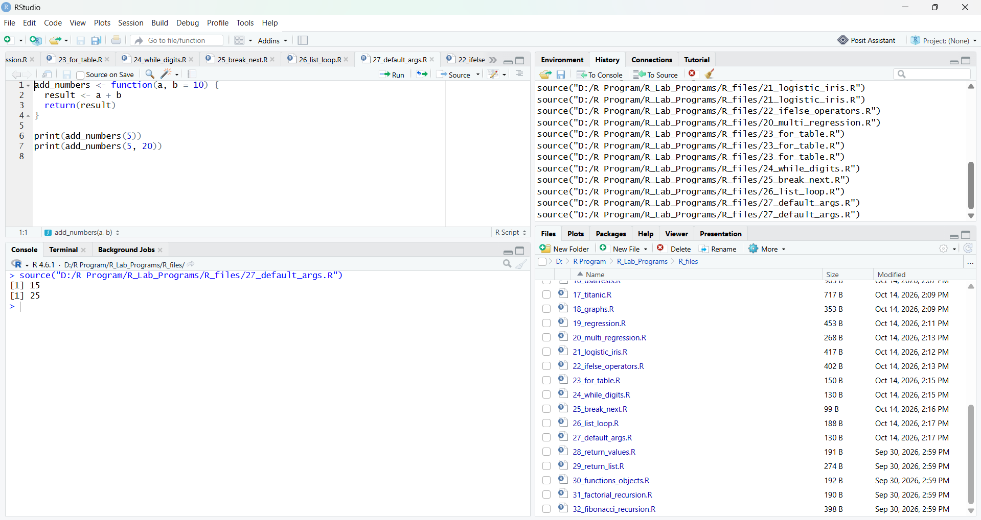RESULT:
Hence the output is verified successfully.
Program 28: Return Values and Explicit return()
AIM:
To write R functions and demonstrate implicit and explicit return of values.
PROCEDURE:
Step 1: Open RStudio or R console on your system.
Step 2: Define a function square_number that computes x * x without using return(); R returns the last evaluated expression (implicit return).
Step 3: Define a function cube_number that computes x * x * x and returns it using return() (explicit return).
Step 4: Call both functions with sample values.
Step 5: Print the results and observe that both types of return give the value to the caller.
PROGRAM (R CODE INPUT):
square_number <- function(x) {
x * x
}
cube_number <- function(x) {
return(x * x * x)
}
print(square_number(4))
print(cube_number(3))
OUTPUT:
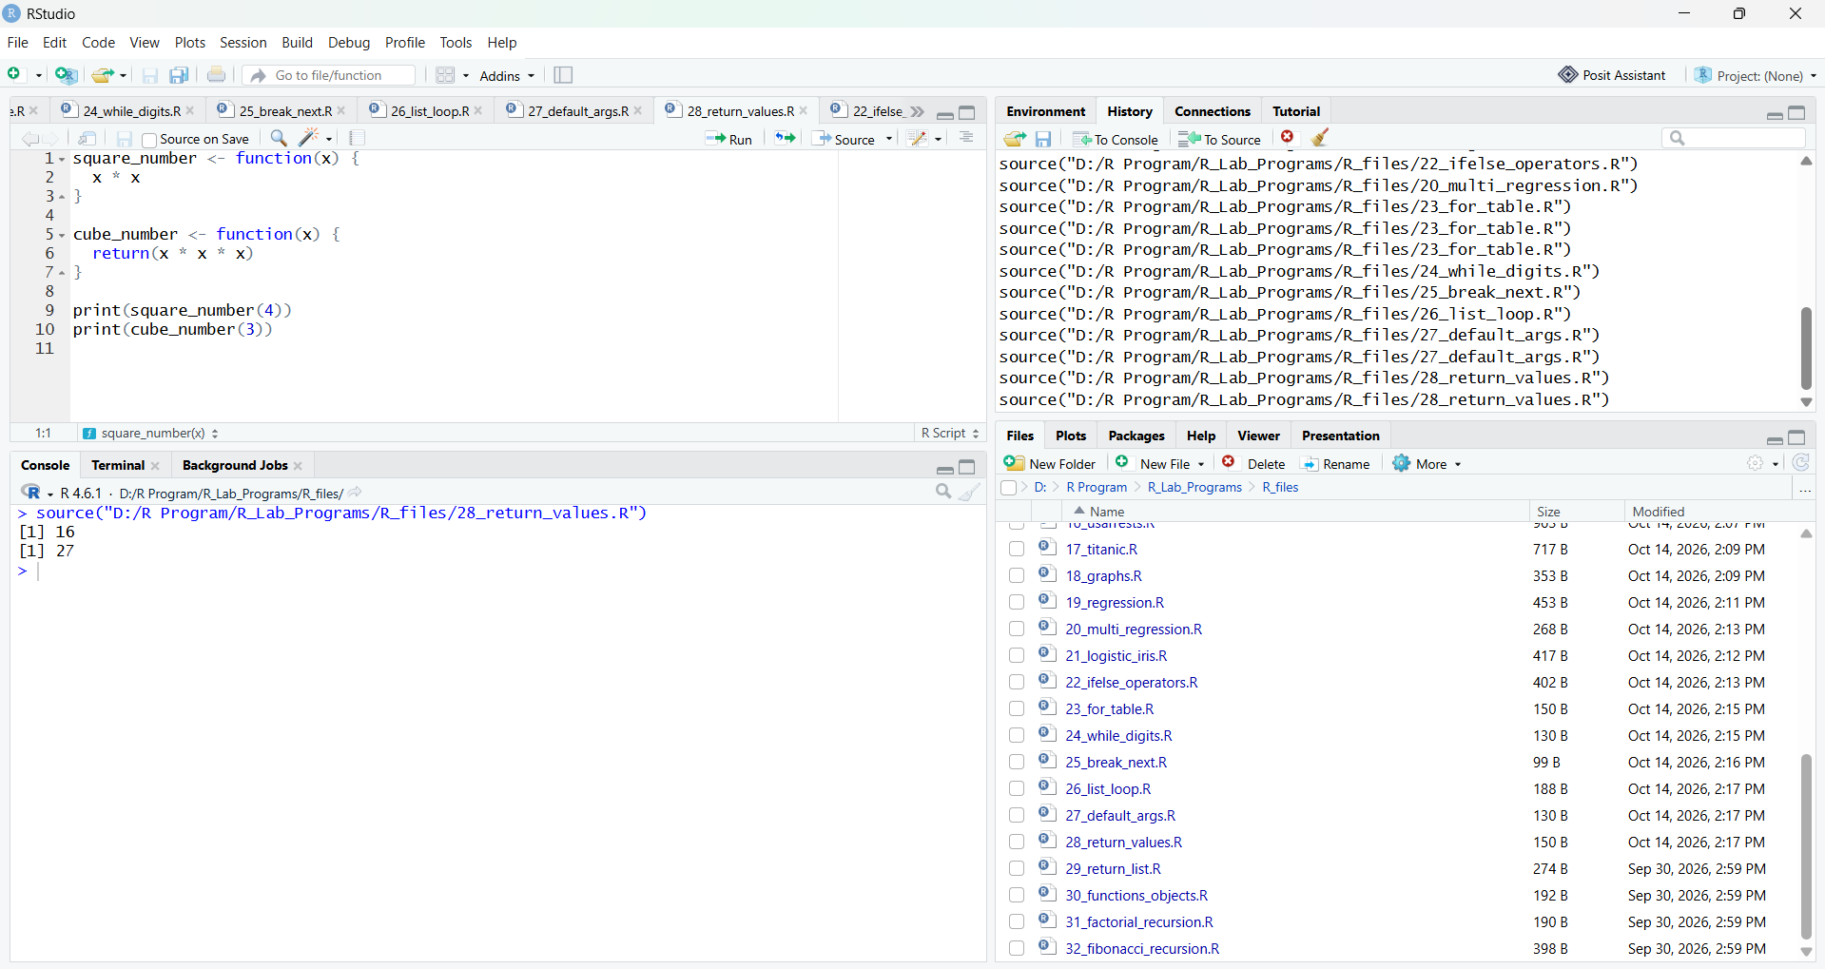
RESULT:
Hence the output is verified successfully.
Program 29: Returning Complex Objects from Functions
AIM:
To write an R function that returns multiple values using a list.
PROCEDURE:
Step 1: Open RStudio or R console on your system.
Step 2: Define a function calculate_stats that takes a numeric vector as input.
Step 3: Inside the function, create a list containing the sum, mean, maximum, and minimum of the vector.
Step 4: Return the list from the function.
Step 5: Create a numeric vector and call the function with it.
Step 6: Print the returned list to view all the values.
PROGRAM (R CODE INPUT):
calculate_stats <- function(x) {
result <- list(
sum = sum(x),
mean = mean(x),
max = max(x),
min = min(x)
)
return(result)
}
data <- c(10, 20, 30, 40)
stats <- calculate_stats(data)
print(stats)
OUTPUT:
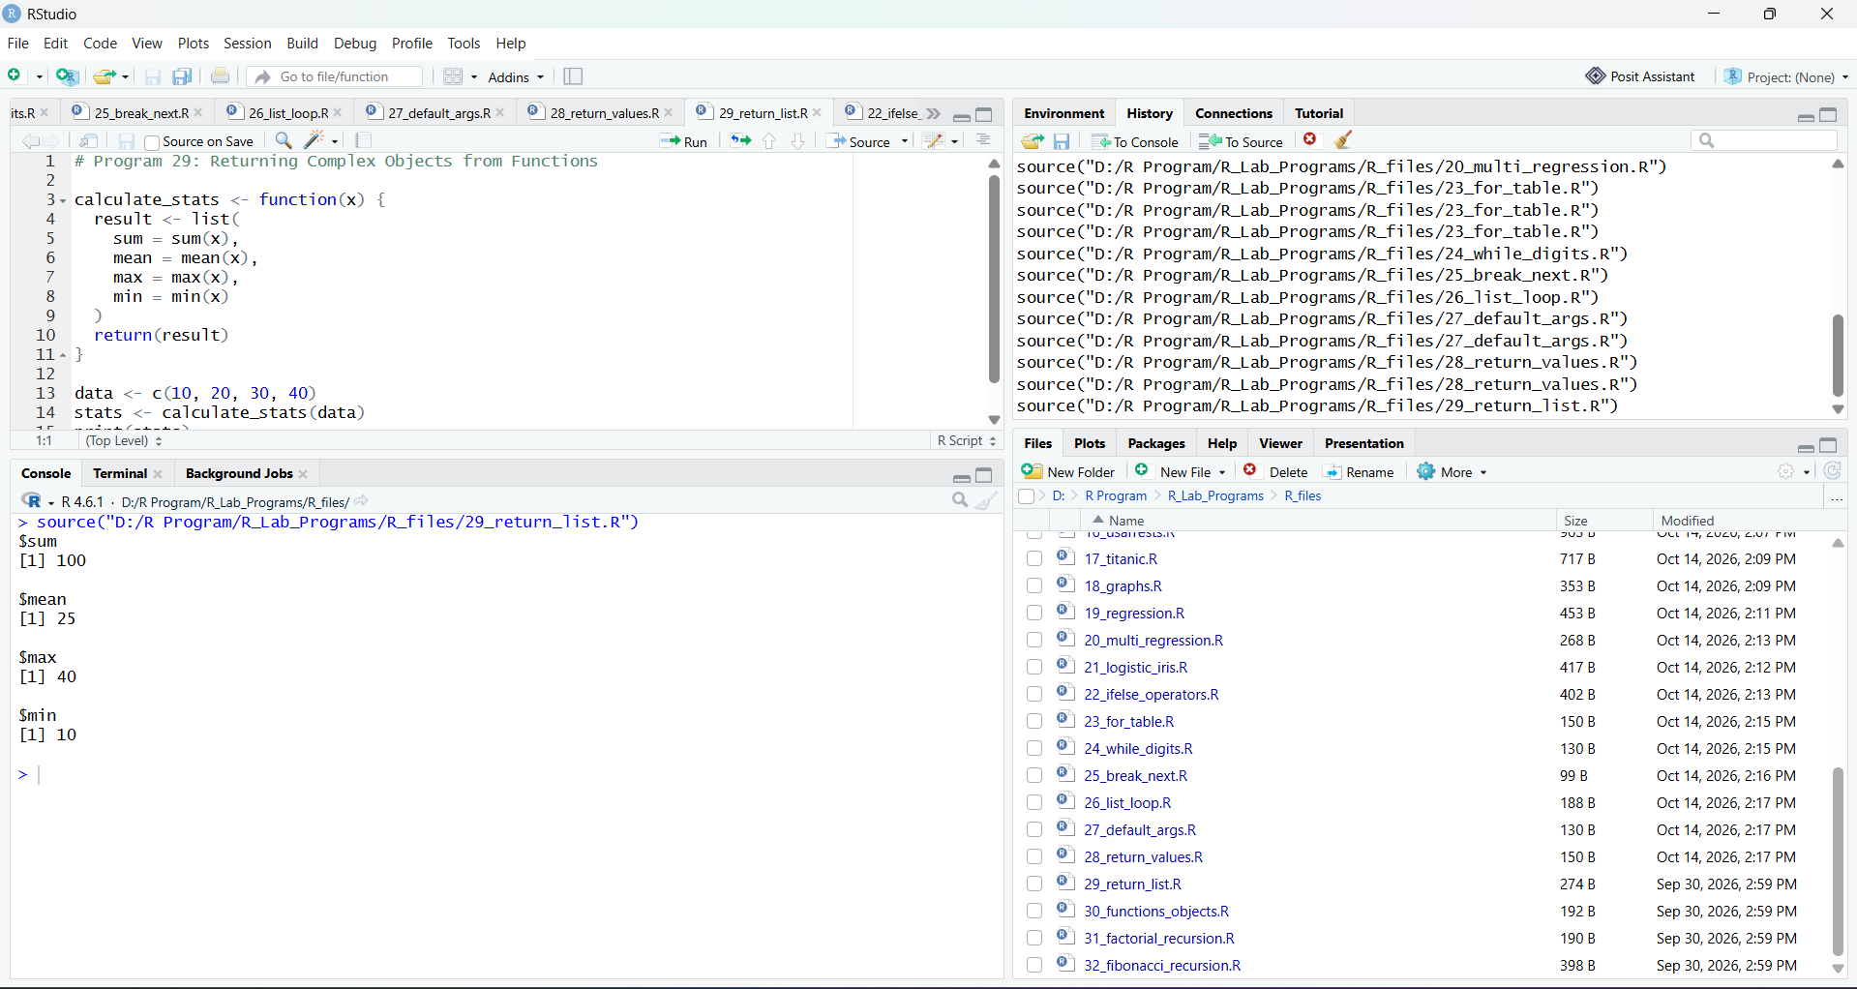
RESULT:
Hence the output is verified successfully.
Program 30: Functions are Objects in R
AIM:
To demonstrate that functions are objects in R.
PROCEDURE:
Step 1: Open RStudio or R console on your system.
Step 2: Define a function my_function that adds 1 to its argument.
Step 3: Use the class function to show that my_function is an object of class "function".
Step 4: Call the function with a sample value and print the result.
Step 5: Assign the function to another variable, another_function.
Step 6: Call the new variable as a function and print the result to show that functions can be stored and reused like objects.
PROGRAM (R CODE INPUT):
my_function <- function(x) {
x + 1
}
print(class(my_function))
print(my_function(10))
another_function <- my_function
print(another_function(20))
OUTPUT:
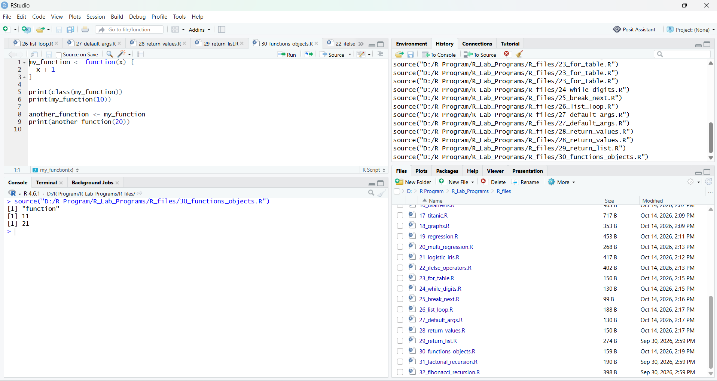RESULT:
Hence the output is verified successfully.
Program 31: Recursion in R - Factorial Program
AIM:
To write a recursive function to find the factorial of a number.
PROCEDURE:
Step 1: Open RStudio or R console on your system.
Step 2: Define a function factorial_fun that takes a number n as its argument.
Step 3: Write the base case: if n is 1, return 1.
Step 4: Write the recursive case: otherwise return n multiplied by factorial_fun(n - 1).
Step 5: Call the function with a sample value (5).
Step 6: Print the factorial value.
PROGRAM (R CODE INPUT):
factorial_fun <- function(n) {
if (n == 1) {
return(1)
} else {
return(n * factorial_fun(n - 1))
}
}
print(factorial_fun(5))
OUTPUT:
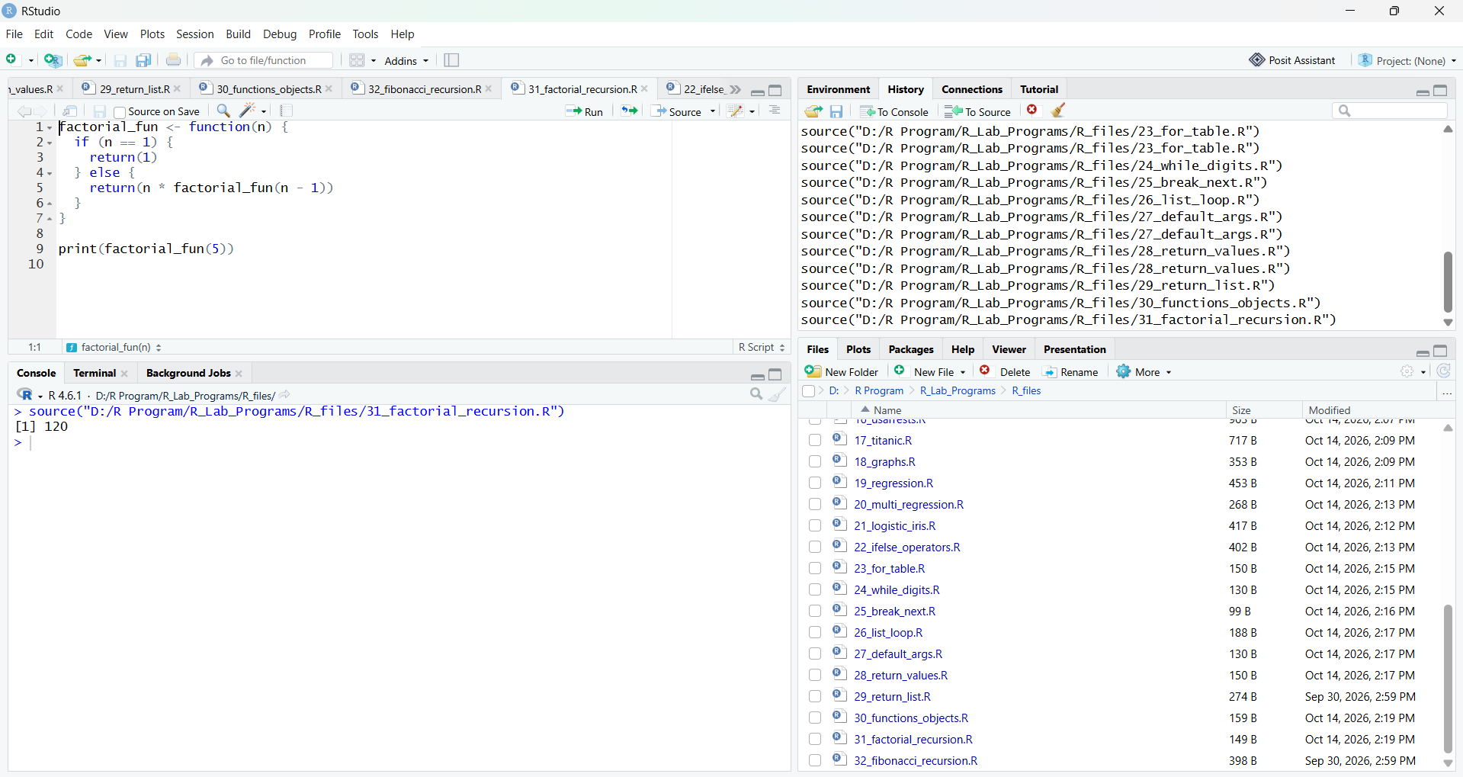RESULT:
Hence the output is verified successfully.
Program 32: Fibonacci Series using Recursion in R
AIM: To write an R program to display the Fibonacci series using recursion.
PROCEDURE:
Step 1: Open RStudio or R console on your system.
Step 2: Define a recursive function fibonacci that takes a number n as its argument.
Step 3: Write the base cases: return 0 when n is 0 and return 1 when n is 1.
Step 4: Write the recursive case: return fibonacci(n - 1) + fibonacci(n - 2).
Step 5: Assign the number of terms to a variable n.
Step 6: Use a for loop to call the function for each term and print the Fibonacci series.
PROGRAM (R CODE INPUT):
fibonacci <- function(n) {
if (n == 0) {
return(0)
} else if (n == 1) {
return(1)
} else {
return(fibonacci(n - 1) + fibonacci(n - 2))
}
}
n <- 10
cat("Fibonacci Series using Recursion:\n")
for (i in 0:(n - 1)) {
cat(fibonacci(i), " ")
}
cat("\n")
OUTPUT:
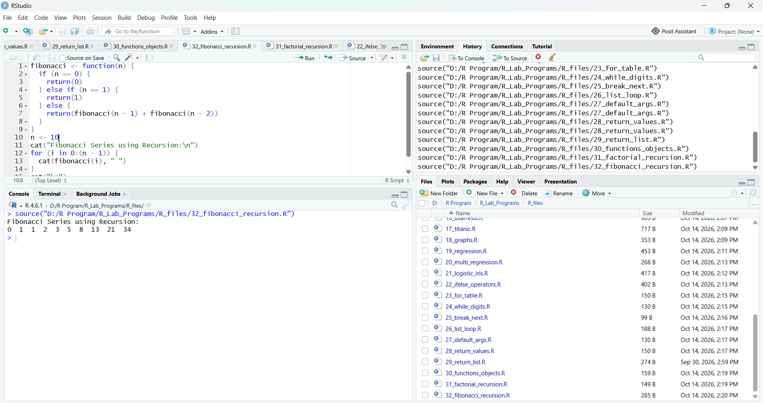RESULT:
Hence the output is verified successfully.

